Data Visualization Final Report
- XML file visualization

Yue Wang
Student number 4406370
yuewang1228@gmail.com

Shenjun Ma
Student number 4420977
mashenjun0902@gmail.com

Abstract
In this project, we want to visualize XML as it could be very hard for users to read especially when the file is large or complex. XML file is based on tag language, and has many attributes to describe the objects inside. We use D3 as a tool to analyze xml and to draw the graphics of the XML content. The view contains tree layout, force layout, pack layout and histogram. And user could get more detail information by clicking to zoom in. Data retrieve and sorting we use javascript.

Keywords
XML, Visualization

INTRODUCTION
Extensible Markup Language (XML) is a markup language that defines a set of rules for encoding documents in a format which is both human-readable and machine-readable. [1] Now it is widely used in web services for the representation of arbitrary data structures because of a lot of advantages it has such as simplicity, openness, extensibility, self-description and so on.
But it is very hard for users to read xml file especially when the file is large and the hierarchy inside is complex. So we want to use the D3 as a tool to analyze xml and give a clear graphic view of the XML content to the users by a simple glimpse.

RELATED WORK
Now a lot of people like to edit the XML file in some professional tools for example XML notepad developed by Microsoft shown in the picture below, see figure 1.
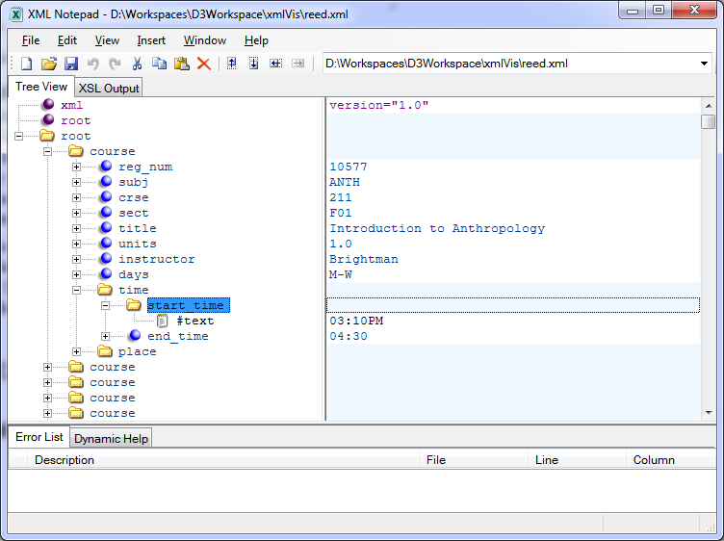
Figure 1
As we can see, the tool is good at displaying the objects in different levels but the restriction of this tool is that it does not show the stucture in a similar resolution and it is hard for the users to compare the differences amoung these objects or to retriece the general information like the behavior of one specific attribute. In this report, we will give the users a general idea of the single attribute behavior and sort the similar objects in a visual method. We classify the XML file into two types that it weather contains many objects or has many hierarchy levels. In the next part we will illustrate these two types seperately.

Data with complex hierarchy
When user gets an xml file, he/she may want to understand the structure of the nodes (tags) in the file. Thus we need to hide may detail information and focus only on the succession relationship. We decide to use tree layout because tree layout can present relationship perfectly. We hide all attribute information in the first graphic. The result is figure 2.
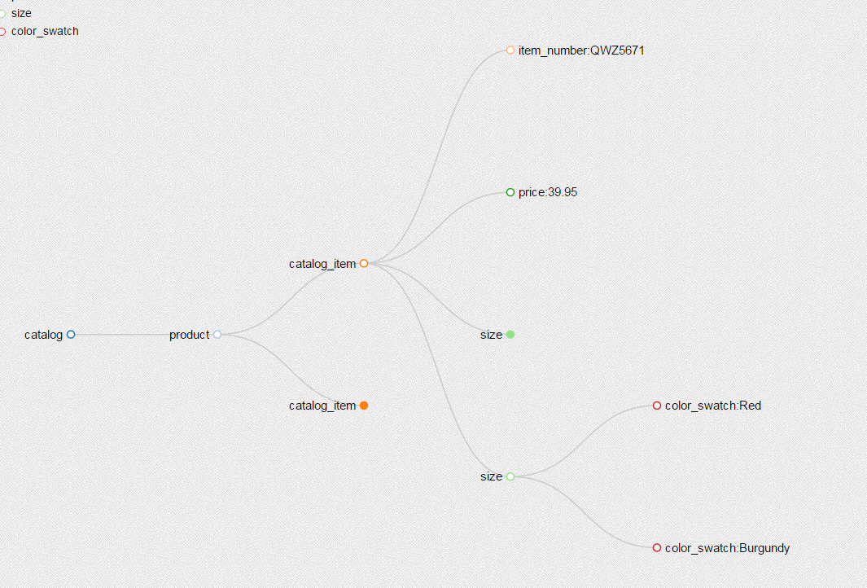
Figure 2
All the nodes can be expanded or collapsed by clicking on the nodes in case there are too many nodes in the xml file. Note that different nodes with different tag name are assigned with different colors. With the interaction and categorical color, users can have a clear vision of the structure.
On other hand, we still need to show the attribute value in a smart way which don’t mess up the structure vision. So we design a tooltip on each node to show corresponding attribute values. The result is shown in figure 3.
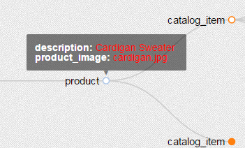
Figure 3
Only see one node’s attribute is not enough. What about users want to see the attributes of multiple nodes? We also design a brush action to show multiple nodes’ attribute value. Just as show in figure 4 and figure 5.
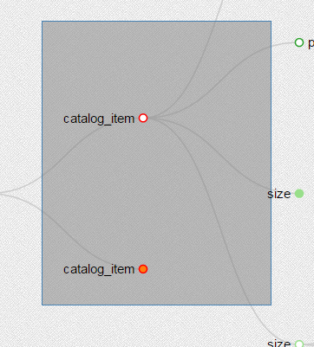
Figure 4
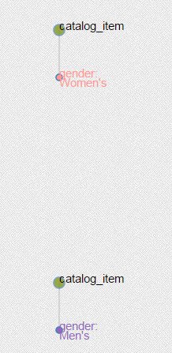
Figure 5
Multiple nodes’ attributes will show in force layout which is another prefect layout to show relationship and nodevalues.
All the structure and attribute visualization is Generics. It works fine with any media size xml file.

Data with huge amount of objects
Supposing we will analyze a XML file called reed. In this file we have all the courses in this university, 668 in total. Each course has 10 sub nodes to show the character of this course and time, place contains further sub nodes. As shown in the figure 1, it has lots of object, but simple hierarchy.
First we would like to see all the courses sorted by one specific attribute, here for example, we represent the number of courses by the start time.
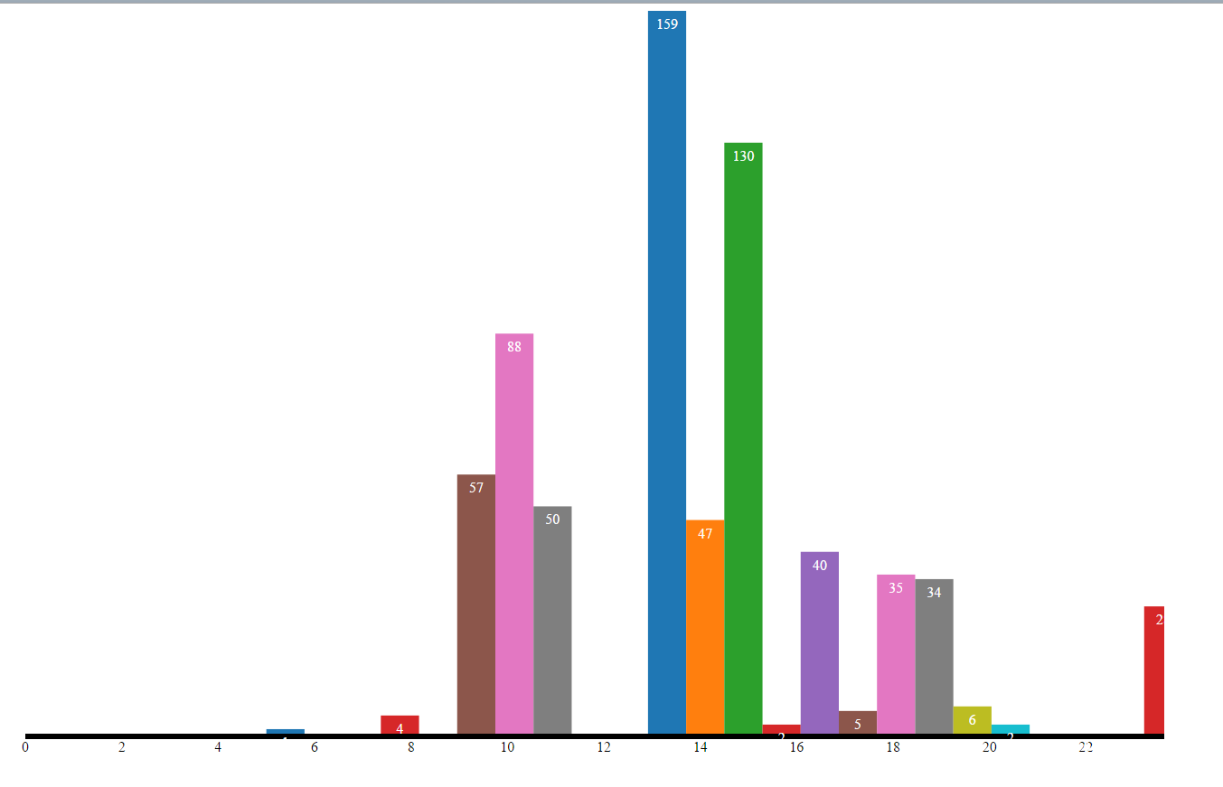
Figure 6
This is the histogram showing how many lecturs starts in a specific time point within a day. Just a simple glimpse we can tell from plot that most lectures are arranged at 9-11 and 13-15. This kind of information might be very useful for the teaching affairs office and may help them to make the schedule to balance the using time of lecture hall.
Second, we would like to see how many objects have the same attribute and show the relationship in a understandable way. Here for example, we would like to display the lectures are instructed by the same professor.
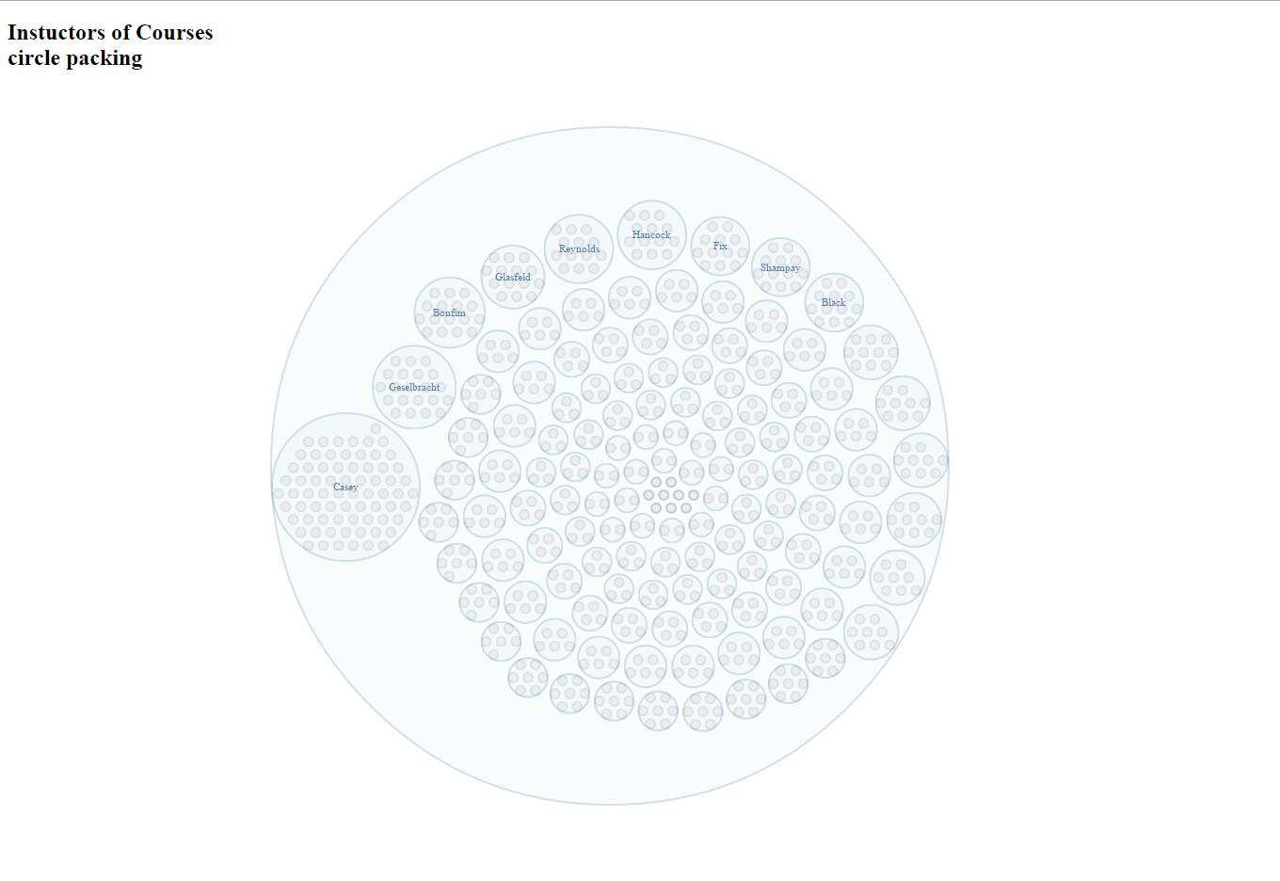
Figure 7
This is a pack graph which shows all the courses by different instrucdor. The bigest circle outside represent the whole domain that is all the courses in our case. Each sub circle represent a professor and the circles inside are the lectures instucted by this professor. It is very intuitive for us to tell which professor has many objects to teach and which is relatively not so busy. And it is easy to compare the instructors by the number of the courses they have and it is easy for human perceiving.
If you want to see more details about a single instructor you can also click the circle to room in and the course names will be displayed as the circle is big enough to contain.
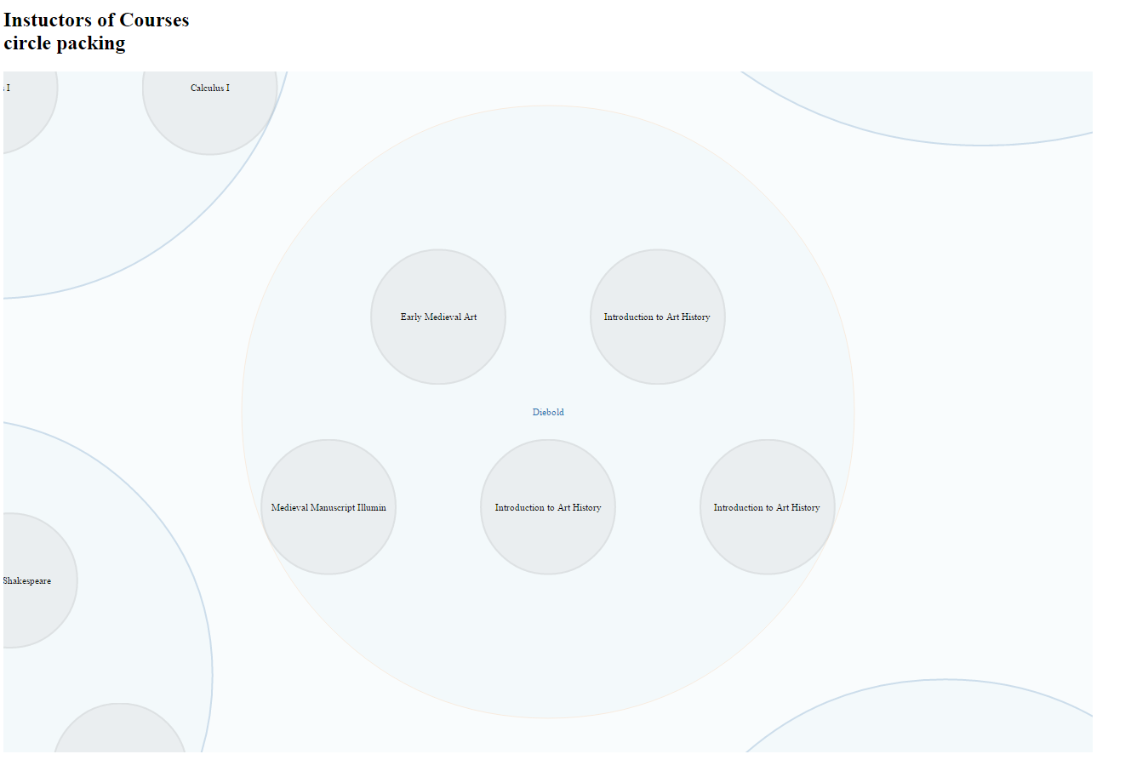
Figure 8

RESULTS
As it is shown in this report, we find a better way to demonstrate XML file. Two classic type of XML file are used in our representation. With this method we successfully achieved the goal that we made in our proposal, which is to give the users a better understanding of the whole XML file in a perceptive way. Further idea is targeting on making an editing module which allow user to edit the content of the XML file by dragging or clicking on the node in the graph. But that is supposed to be a fully-functional application which is not strongly related to our visualization.

REFERENCES

[1] XML – Wikipedia - http://en.wikipedia.org/wiki/XML
[2] D3gallery https://github.com/mbostock/d3/wiki/Gallery

PS: the links to our project:
http://mashenjun.github.io/DataVis/Histogram.html
http://mashenjun.github.io/DataVis/Pack.html
http://mashenjun.github.io/DataVis/XMLViewbook.html
http://mashenjun.github.io/DataVis/XMLViewcomplex.html

